What is strategy?

Strategy at its most basic level is just a collection of actions to achieve some kind of goal, there are many ways a strategy could be developed and in most cases the exact methods you use will be dependant on the culture of the organisation, the resources available to you and in some cases how many people are involved in the strategic planning process.

Types of strategy

There are two types of strategy, emergent and deliberate.

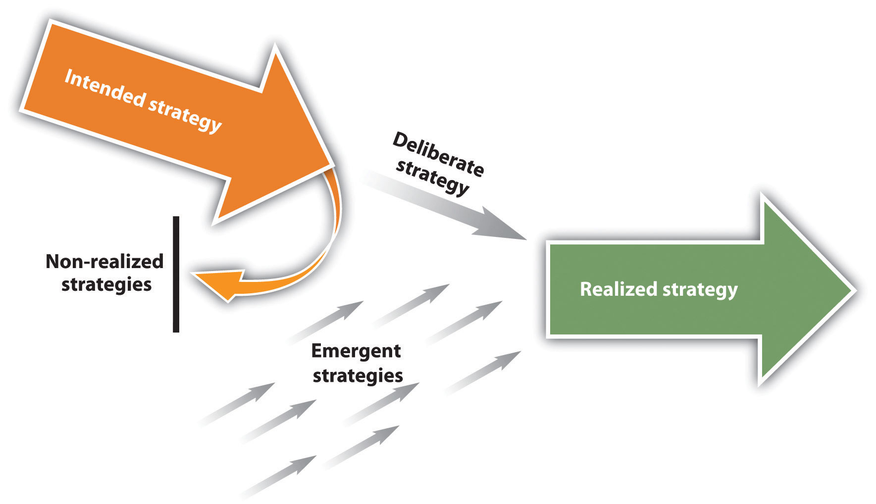

Emergent strategy is also known as accidental strategy and it doesn’t mean that there was no plan only that the eventual strategy wasn’t the one originally envisioned by the organisation, a good organisation will allow room to embrace any emergent strategy that emerges and is in many ways the far more interesting type of strategy, an example of this is the development of NyQuil where they developed a cold medicine that kept putting people to sleep so they rebranded it into a nighttime cold remedy instead.

A Deliberate strategy is one that’s been planned from the start and then follows through until completion, it is the result of in-depth planning sessions and identifying the course of action they should take to accomplish this, an example is Frederick Smith who had a vision for overnight shipping across the United States and started FedEX.

The chances of a strategy being entirely emergent which indicates no control of any kind and entirely deliberate which indicates no learning as everything went exactly as was designed, a deliberate strategy is best used in a stable unchanging environment which is rare in the modern era, the few obvious examples are things like airports and ports where there are few if any alternatives and big strategies can be developed over many years (such as a new runway) incorporating technology available at the outset.

How to develop strategy

According to Henry Mintzberg there are 9 schools of thought on developing a strategy for an organisation or business unit.

Design

Planning

Positioning

Entrepreneurial

Cognitive

Learning

Power

Culture

Environmental

Configuration

Design school

This school is one of the oldest having appeared in 1965 at Harvard university and is well suited to general case study analysis (as popularised by their teaching style). This school uses the well-known SWOT analysis, this analysis is then used to create a series of strategies to choose from, in order to pick the "best" strategy it should be analysed for four things:

1. Consistency - It should not present mutually inconsistent goals and policies.

2. Consonance - It should adapt the organisation to the external environment and its changes.

3. Advantage - It should provide for the creation and/or maintenance of a competitive advantage.

4. Feasibility - It may be obvious but the strategy must be possible given the available resources and not create other unsolvable problems.

Planning school

This school builds on the design school and adds a large number of procedures to quantify the goals of the organisation (which they call objectives) and unlike the design school separates goals from the actual strategy. This school looks at forecasting and trying to predict what will happen within the competitive environment with one of the most common and complex being scenario planning, this school formalises the design school using 3 main points.

1. Strategies come from a formal process supported by techniques.

2. The process is the responsibility of the CEO (or whoever is in charge) and is the executed by the planners.

3. A strategy will appear fully formed, this is then explicitly enforced using objectives, budgets, programmes and operating plans.

Positioning school

This school works on the principle that there are only a finite number of strategies available with which to defend your position and ultimately expand and grow in the marketplace. The logical extension of this is that there are only a few generic strategies to pick from and you don't need to spend time generating bespoke ones for your organisation just pick from the predefined list. This is characterised by Michael Porters competitive analysis which looks at 5 elements:

1. The power of your suppliers - generic vs custom goods, number available etc..

2. The power of your buyers - do you supply unique goods, brand loyalty, price sensitivity etc..

3. The threat of new entrants - how easy is it to compete, government regulation, capital requirements etc..

4. Substitutes - Alternative options, cost of switching etc..

5. Industry Competition - Is the competition fierce or is there room for cooperation

Entrepreneurial school

This school is very focused on the individual as the entrepreneur and how they come up with their vision for the organisation, this vision is expressed in terms of an image of how things should be rather than developing a hard plan to get there. This school uses the concept of creative destruction (as popularised by Jospeh Schumpter), the entrepreneur is the source of ideas. It can be summed up in 4 points:

1. Strategy making is dominated by the active searching for opportunities

2. Power is centralised in the chief executive

3. Strategy making is characterised by large leaps forward in the face of uncertainty

4. The overriding goal is growth.

Cognitive school

This school concentrates on the how of strategy formation and treats it as a mental process, one of the founding principles is figuring out how a strategist forms strategies and then formalising this process. This is the first school which actively looks for the built in bias we all have and how it affects the strategy formation such groupthink.

The school examines information processing as "mapping" where basic data can be taken and applied to mental maps in order to develop strategy, this will include a range of assumptions and as more information is gathered the map may change to discard those that no longer fit the available data. The school can be summed up in 4 points:

1. Strategy is formed as a cognitive process in the strategist’s mind.

2. The strategy formed is an individual's (or groups) perspective having formed from concepts, maps, frames etc..

3. The inputs flow through distorting filters before they reach the cognitive steps and are already "tainted" by perception of the world

4. Strategies are inherently concepts, difficult to obtain, never optimal and difficult to change when no longer viable.

Learning school

This school is based on the notion that all strategy is emergent and thus no strategy will be 100% perfect and the strategist will need to learn from the things that went wrong (and right) during a strategic implementation. Too often the senior management invent strategies that are isolated from the realities of those on the front line causing an implementation failure, this leads on to the logical conclusion of a failure in implementation also being a failure of formulation.

The biggest component of this school (unsurprisingly) is how to learn from the results of a strategy implementation, this takes the form of reflection on events and identifying at what point it deviated into an emergent strategy.

Power school

This school will be very familiar to anyone that's worked in a large organisation, it treats the strategy formation process as a negotiation between individuals and ties it intimately with politics. The school breaks down power into two major groups.

1. Micro power - this deals with the use of power (of all kinds) within the organisation (such as discussing the divesting of a business unit or division)

2. Macro power - this deals with the use of power by the organisation itself (such as pressuring the government for implicit loan guarantees)

The school looks at how those "at the top" use their power and political clout to get what they want within the organisation and to allow them the discretion to shape their domains how they see fit. There is a lot of analysis on the political manoeuvrings required to get your strategy accepted including the use of cooperative strategy making using your social network and collective strategies and then applying this on the macro level to create strategic alliances with other organisations to enable both to survive.

Culture school

This is almost the exact opposite of the power school and instead of individuals fighting for control everybody works together for a common goal defined by the culture of the organisation (which could in fact lead to the resistance of strategic change). The 5 beliefs of this school are:

1. Strategy is formed by social interaction based the shared beliefs

2. Any given individual will gain these beliefs through socialisation and acculturation which is largely unspoken.

3. A member of the culture will find it hard to describe the underlying beliefs.

4. Strategy is formed by perspective more than positioning, it is reflected in how the resources and capabilities and protected and used for competitive advantage.

5. The cultural ideology does not encourage strategic change and will tend towards maintaining the status quo at best it will promote shifts of position within the current strategic vision.

Environmental school

The environmental school is reactive rather than proactive, it works on the principle that the external forces to a company reduce the available options to it and force it into a given course of action, it has 5 main points.

1. The environment presents itself to the organisation and is the central figure in strategy making.

2. The direction is set during the formation of the organisation and is becomes harder to respond to changes.

3. The long term survival of the organisation is based on these original choices.

4. As time goes on the leadership is less able to influence the performance and survivability of the organisation.

5. If an organisation does survive it tends to cluster with similar organisations into niches where they share technology, management styles and products.

Configuration school

The configuration school treats strategy as a transformative process, this approach is used a lot in social sciences but has not fared well in those industries that are obsessed with things being scientific. This school is best described by the famous Stephen Gould quote "The history of any one part of the earth, like the life of a soldier, consists of long periods of boredom and short periods of terror", this school encompasses all other schools and defines them in a well defined context. It can be summed up in 6 points.

1. An organisation can be described as a stable configuration which can give rise to a particular set of strategies.

2. The period of stability rising to this configuration is followed by a process of transformation.

3. These stable configurations may over time order themselves into patterns describing an organisational lifecycle.

4. The strategy is to maintain adaptability but also recognise the need for major transformation and manage the process without destroying the organisation.

5. The strategy making process is one of conceptual design using the other schools each used as appropriate with each one representing a particular configuration.

6. Each strategy is a series of patterns, positions or perspectives but each one is matched to its own time and situation.